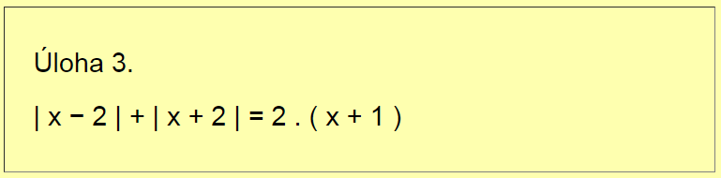

Nulové body:

I1 I2 I3

|  |  |  |  |
| --- | --- | --- | --- |
|  |  |  |  |
|  |  |  |  |
|  |  |  |  |

K =

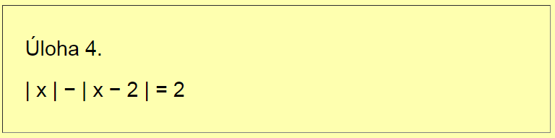

Nulové body:

I1 I2 I3

|  |  |  |  |
| --- | --- | --- | --- |
|  |  |  |  |
|  |  |  |  |
|  |  |  |  |

K =

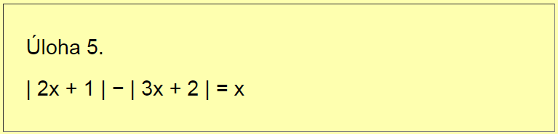

Nulové body:

I1 I2 I3

|  |  |  |  |
| --- | --- | --- | --- |
|  |  |  |  |
|  |  |  |  |
|  |  |  |  |

K =

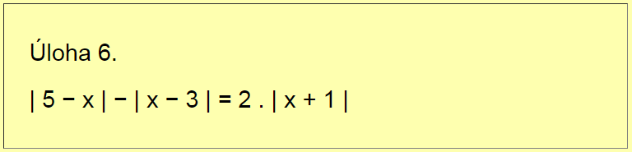

Nulové body:

I1 I2 I3

|  |  |  |  |
| --- | --- | --- | --- |
|  |  |  |  |
|  |  |  |  |
|  |  |  |  |

K =